Addressing leadership, productivity, and informality for women in Small and Medium Enterprises

Introduction
The third issue of the Indonesia Gender Dashboard examines leadership and productivity of Indonesian women in both the formal and informal private sector. This issue draws from recent flagship World Bank data collection efforts and proposes areas of public-private collaboration to increase women’s access to formal jobs in productive sectors in the country, as well as promote woman leadership in private businesses.
The first key data source used in the analysis is the World Bank Enterprise Surveys (ES) implemented multiple times in Indonesia: 2009, 2015, and 2023. The 2023 ES survey is the most recent available firm level data for the country, gathering information from 2,955 interviews with top managers and business owners in the country. This gender-disaggregated data covers a broad range of topics related to the business environment as well as firms’ characteristics and performance, including management practices, workforce, trade, innovation, and technology.
The second key data source is the World Bank Informal Sector Enterprise Survey (ISES) 2023 providing a deep-dive into practices and challenges of 5,352 informal enterprises in Indonesia. This is a unique database of businesses often excluded from standard survey exercises due to their lack of Business Identification Number (NIB) and related absence in taxation processes. The survey employs instruments analogous to those used in the Enterprises Surveys, with additional modules pertinent to informal enterprises. Given the difficulty of collecting such data, the 2023 ISES focused on a sample of firms in six cities in Indonesia: Jakarta, Surabaya, Medan, Makassar, Denpasar, and Pontianak. Comparison between formal and informal firms in this publication will only pertain to these cities.
The analysis has also been enriched by the Indonesia Business Pulse Survey (BPS). As part of a global initiative led by the World Bank and its partners, the BPS survey examines the impact of COVID-19 on the private sector worldwide through a panel study design. It collects comprehensive data on firms' operational statuses, channels through which their activities are affected, access to finance, availability and utilization of policy support, and the adjustment strategies employed. There were five rounds of BPS in Indonesia between 2020 and 2022.
The remainder of the issue is organized as follows. Starting with comparing firms‘ characteristics, the issue then discusses leadership and productivity differentials between women- and men-led businesses across various firm sizes. Potential barriers to productivity are then assessed, complemented by a discussion on the role of technology adoption as a strategy to improve productivity. The issue concludes with a set of actionable policy recommendations, specifically aimed at fostering productivity and strengthening women's leadership in the private sector.

Overview of firms by formality
- Informal enterprises are mostly microenterprises in services, while formal firms are SMEs, with more in manufacturing.
- Higher compliance costs and regulatory burdens deter formalization.
- Informality offers flexibility, low costs, and proximity to family responsibilities but face limited growth opportunities.
- Informality is prevalent in services regardless of regions, while formal manufacturing is predominant in North Sumatra.
- Women-led businesses are equally present in informal and formal sectors, reflecting gender parity in entrepreneurship.

Size and sectoral overview
The comparison between formal and informal firms in this section is bounded by the difference between sampling frames for ISES and ES surveys. ES purposely excludes micro firms from its sampling frame (2016 Indonesia Economic Census), despite these firms constituting nearly 90 percent of businesses. By comparison, the ISES employs an area-based method due to the informal sector’s lack of a structured sampling frame. Hence, according to the ISES, most informal businesses in sampled areas are microenterprises (Figure 1), contrasting with a distinctly different structure for formal businesses: 95.8 percent are SMEs, and 4.1 percent are large firms. More informal businesses operate in services compared to formal firms where manufacturing seems preferred. The share of services formal firms is 12.4 percentage points less than informal firms.
The lower share of informal firms engaging in manufacturing indicates the perceived costs of formalization by small businesses, such as higher operational costs driven by compliance requirements and regulatory burdens. For instance, setting up a small refreshment kiosk or food stall involves fewer administrative steps than initiating a regulated business in manufacturing, such as pudding production, which entails formal registration, minimum size for the workforce, quality control, and compliance with stringent safety standards.
Business owners may then intentionally choose informality to secure income without the complexities often linked to formalization processes. As reported by ISES respondents, informal enterprises provide an essential means to accumulate wealth and offer flexible working arrangements. Unlike formal businesses, they often require minimal startup capital and are subject to fewer regulatory demands. Hence, informal work can be appealing due to its adaptability and proximity to family responsibilities, particularly enabling women to avoid the high costs and rigidities of the formal sector. However, informality limits firms' access to formal financial services, government support programs, and broader market opportunities, thus impeding their growth.
Figure 1: Size and sector distribution by formality
Source: Authors’ calculation based on ES 2023 and ISES 2023. ES sample is limited to ensure consistency with the ISES sample. Sampling weight is used.
Services dominate across all six regions of Indonesia in comparison to the manufacturing sector (Figure 2). Informal services are concentrated in Sulawesi at 99.1 percent, followed by Jakarta at 98.3 percent and North Sumatra at 95.6 percent. Formal services show the highest concentration in Bali at 90.7 percent, followed by Sulawesi at 89.7 percent, and Jakarta at 87.3 percent. The informal manufacturing sector is concentrated in East Java at 6.3 percent, , while North Sumatra leads formal manufacturing at 30.8 percent. The significant disparity between informal and formal manufacturing sectors constitutes another illustration of sectoral- specific registration requirements which drive more formality. .
Figure 2: Manufacturing and service sectors distribution across regions
Source: Authors’ calculation based on ES 2023 and ISES 2023. ES sample is limited to ensure consistency with the ISES sample. Sampling weight is used.

Firms’ leadership and gender
The issue defines women-led businesses as those in which at least one of the owners is a woman. . An alternative approach would be to define women-led businesses based on the presence of women in top management positions or as most of the workforce. However, given the limitations of ISES data for informal businesses, having at least a woman owner among the business proprietors can serve as a practical proxy for standardizing the definition of leadership in line with formal businesses.
The anecdotal claim that women predominantly lead informal enterprises is not substantiated by findings from the ISES 2023 (Figure 3). The proportion of women-led businesses is consistent across both informal and formal sectors, suggesting that women entrepreneurs are not confined to the informal economy. The Global Entrepreneurship Monitor (GEM) reports from 2015 and 2020 present similar findings, indicating that the proportion of women and men entrepreneurs in Indonesia is the same. This suggests a leveled playing field in the entrepreneurial landscape. The absence of disparity in leadership indicates a conducive environment for entrepreneurship, where women are positioned to engage in business activities on par with their men counterparts.
Figure 3: Women and men leadership distribution between business formality
Source: Authors’ calculation based on ES 2023 and ISES 2023. ES sample is limited to ensure consistency with the ISES sample. Sampling weight is used.

Women leadership and business size
- Women lead large formal businesses but are less represented in small informal firms.
- Women-led businesses are concentrated in Bali (informal) and East Java (formal), influenced by local policies, cultural norms, and community support.
- Women are underrepresented in top management and critical decision-making roles, regardless of business size or sector.
- Women managers actively engaged in export markets, enhancing firm performance, and demonstrating the potential of inclusive leadership.
- Women-led enterprises employ more women, reflecting gender-sensitive hiring practices.
- Women-led businesses are more likely to offer maternity leave than men-led businesses, but both face challenges in providing extended leave durations due to size-related resource constraints, highlighting a gap between practice and legal requirements.
Across different business sizes, in both the informal and formal sectors, women hold leadership positions to varying degrees. In the informal sector, only small businesses exhibit less than 50 percent women leadership (Figure 4). In contrast, 60 percent of large businesses in the formal sector are led by women. This must be caveated by the limitations of the analysis which is based on data from six selected cities in the ISES sample, suggesting that women business leadership is balanced across major urban areas.
Figure 4: Firm size distribution between gender leadership and business formality
Source: Authors’ calculation based on ES 2023 and ISES 2023. ES sample is limited to ensure consistency with the ISES sample. Sampling weight is used.
A notable regional disparity exists regarding business leadership by women, despite previous observations indicating no significant differences when considering company size (Figure 5). Women-led informal businesses are predominantly found in Bali, followed by West Kalimantan and Jakarta, while women-led formal enterprises are most prevalent in East Java, Sulawesi, and North Sumatra. The higher prevalence of women-led informal businesses in some regions may be linked to the specialization of those areas in sectors favored by women, but also indicate a supportive community environment and cultural acceptance of women entrepreneurship. In contrast, the concentration of formal businesses led by women in other regions may reflect the presence of supportive policies and/or business licensing designed to foster women entrepreneurship.
Regional policies supporting women-led businesses could also foster stronger female entrepreneurship in certain regions. In areas with targeted programs, women entrepreneurs benefit from increased access to training, finance, and networks. However, challenges persist, including limited formal business opportunities due to societal norms, remaining financial barriers, and informal sector constraints. In regions lacking specific support policies, resources for women entrepreneurs are further limited. Government and NGO initiatives aim to bridge these gaps, but their effectiveness varies based on local context and implementation practices.
Figure 5: Women leadership across regions
Source: Authors’ calculation based on ES 2023 and ISES 2023. ES sample is limited to ensure consistency with the ISES sample. Sampling weight is used.
Taking a closer look at the workforce within the firms shows interesting results. First, compared to men, women leaders do not significantly prefer women managers but have a relatively gender-balanced top management in their businesses: 97.3 percent of top managers in the former are men compare to 47.7 percent in the latter (Figure 6). Second, when disaggregating by firm size, the percentage of women top managers remain consistently below 6 percent with medium enterprises performing better than large and small firms (Figure 7). This could be illustrating discrimination in promotion opportunities or even at entry where women are preferred for low-skilled roles with less room for growth.
Figure 6: Top managers gender between men- and women-led businesses | Figure 7: Women as top managers between men- and women-led across size
Source: Authors’ calculation based on ES 2023. Sampling weight is used.
The observable disparity in women's representation in managerial positions does not necessarily correspond to differences in firms' structural characteristics. Regardless of leadership or the specific roles women hold in management, they remain underrepresented across nearly all critical decision-making domains. This underrepresentation extends to areas such as sourcing inputs through imports, participating in export markets, providing training, and engaging in foreign investment activities (Figure 8 and Figure 9). The limited presence of women in these key functions highlights persistent gender imbalances within corporate leadership, which may, in turn, impact the strategic directions and operational effectiveness of firms.
Despite these challenges, women managers demonstrate a notable inclination toward participating in export markets (Figure 9). Participation in export activities is frequently a recurring decision within the manufacturing sector. This strategic preference is significant, as prior studies suggest that firms involved in export activities are more likely to achieve higher sales. Moreover, this positive sales effect is further enhanced when firms engage in both importing and exporting activities. Thus, the active involvement of women managers in export markets may not only contribute to the firm's international presence but also position it for better financial performance. This finding underscores the potential benefits of increasing women's participation in decision-making roles, particularly in areas that directly influence a firm's competitive advantage and growth.
Figure 8: Characteristics between gender leadership | Figure 9: Characteristics between gender of manager
Source: Authors’ calculation based on ES 2023. Sampling weight is used.
Women-led enterprises employ substantially more women workers than to those led by men, reflecting potentially gender-sensitive employment practices that could foster inclusive work environments. As illustrated in Figure 10, women constitute 91.1 percent of the workforce in women-led enterprises within the informal sector, contrasting sharply with the 46.8 percent women workforce in men-led enterprises. This pattern persists in the formal sector, where women-led enterprises employ 12.8 percent more women than their men-led counterparts. Such statistics suggest that women leaders may be more inclined to hire women employees, possibly due to an understanding of the unique sociocultural challenges women face in balancing professional and domestic responsibilities, and a desire to create supportive workplace conditions. Despite the informal sector’s limited provision of formal contracts, widespread use of part-time roles, and reliance on unpaid labor, these conditions may inadvertently accommodate women workers’ need for flexibility, supporting a model that aligns with their distinct responsibilities and availability. This flexibility is particularly significant given that women often bear greater household obligations, which can restrict their ability to adhere to a standard 40-hour workweek, thereby constraining their participation in more regulated sectors. Additionally, the prevalence of informal sector roles can provide critical economic opportunities for women, enabling them to contribute to household income without the rigid requirements of formal employment. Consequently, the informal sector may serve as a pragmatic alternative for women seeking employment, even as it remains outside the formal regulatory frameworks that ensure comprehensive protections for businesses and employees alike.
Figure 10: Share of women workers by gender leadership and formality
Source: Authors’ calculation based on ES 2023 and ISES 2023. ES sample is limited to ensure consistency with the ISES sample. Sampling weight is used.
Women-led businesses in the formal sector exhibit distinct maternity leave practices compared to men-led enterprises, as shown in the Figure 11. Overall, women-led businesses are more likely to offer maternity leave. However, company policies regarding the provision of maternity leave vary by business size. Notably, the likelihood of a business offering maternity leave to women workers increases with its size. Understandably, this pattern also extends to the duration of maternity leave, with larger businesses generally providing longer leave periods. However, men-led businesses consistently offer longer maternity leave across all business sizes, except for large enterprises, where women-led businesses slightly exceed their men-led counterparts in leave duration.
Both men and women-led businesses are less likely to offer maternity leave as business size decreases. Similarly, shorter maternity leave durations are also observed in smaller businesses. These findings suggest resource constraints or operational challenges associated with the limited number of employees. The shorter leave durations provided by smaller businesses may reflect a trade-off between offering maternity leave benefits and maintaining business continuity.
Figure 11: Maternity leave by gender leadership
Source: Authors’ calculation based on ES 2023. Sampling weight is used.

Businesses productivity by gender of ownership
- Women-led medium enterprises show higher labor productivity than men-led businesses, but this advantage declines as firm size increases, particularly in larger enterprises.
- Women business leaders who implement effective human resource management practices tend to have higher labor productivity, while men focus more on product knowledge to boost productivity.
- Women-led small and medium-sized businesses demonstrate competitive total factor productivity (TFP), often matching or surpassing their men counterparts in operational efficiency.
- In the informal sector, women-led businesses are more likely to rely on interpersonal skills and relationship-building in their practices, whereas men-led businesses tend to focus on strengthening operational planning and financial recordkeeping to achieve strong performance.

Formal businesses
Gender disparities in productivity become increasingly pronounced as firm size expands. Figure 12 illustrates the distribution of labor productivity across firms of varying sizes, categorized by the gender of leader. Women-led businesses demonstrate higher labor productivity compared to their men-led counterparts, especially within the context of medium enterprises. However, as firms grow larger, a notable decline in labor productivity becomes apparent among women-led businesses relative to those led by men. This disparity becomes more pronounced in larger enterprises and is particularly concentrated at the lower end of the productivity distribution. The widening gap in productivity as firm size increases may reflect structural challenges or barriers that women-led businesses face as they scale.
The distributions suggest that women-led firms may exhibit more efficient labor practices or management strategies at smaller scales. As illustrated in the lower panel of the figure, the estimation results suggest that women business leaders who implement human resource management practices, particularly in reassigning tasks and/or dismissing employees, demonstrate a strong and positive association with labor productivity. Conversely, men business leaders who emphasize product knowledge practices also show a positive association with labor productivity.
Figure 12: Labor productivity distribution and estimates subject to management practices
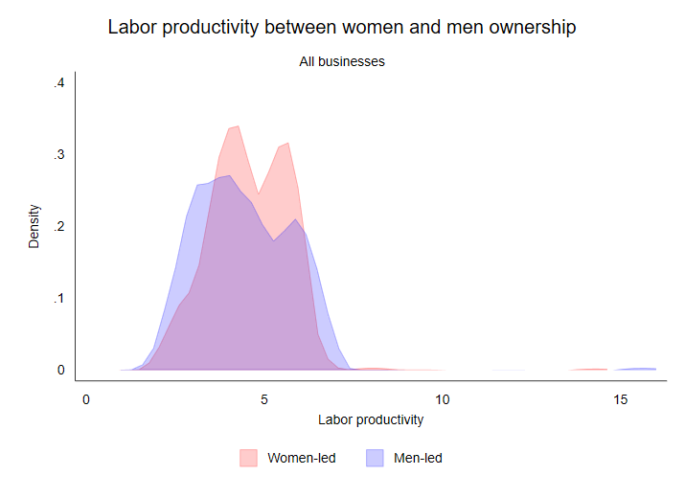 | 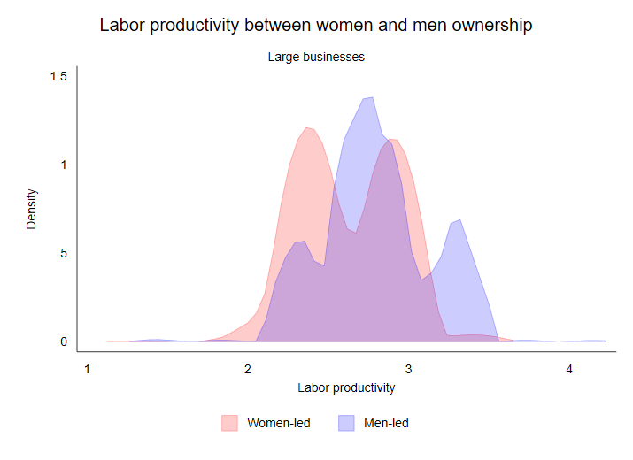
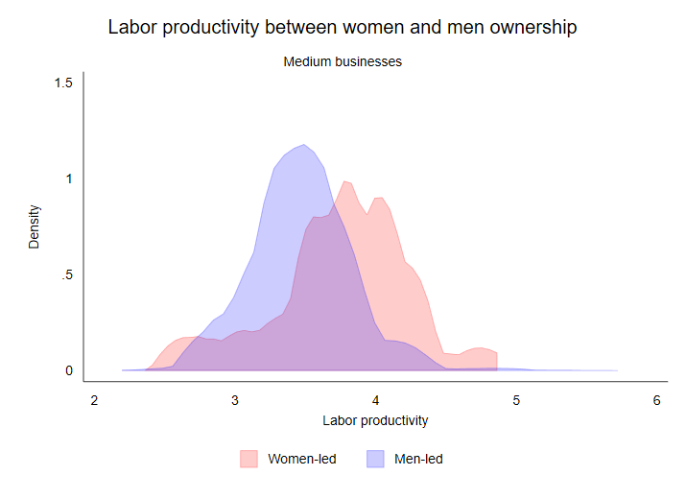 | 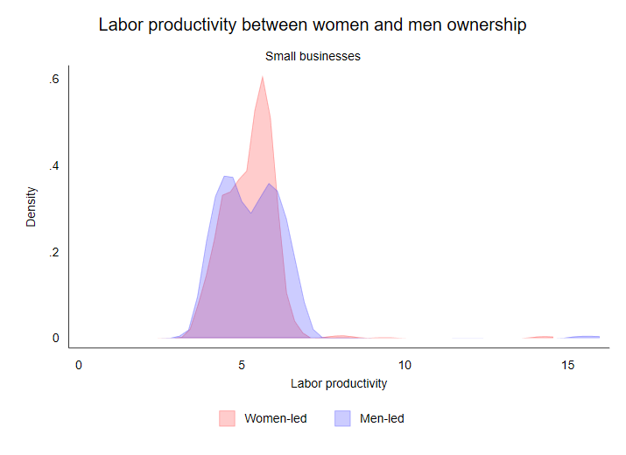
Source: Authors’ calculation based on ES 2023. Sampling weight is used.
Despite the disparity in labor productivity observed in the formal sector among larger enterprises, women-led small and medium-sized businesses may exhibit competitive levels of total factor productivity (TFP) relative to their men-led counterparts (Figure 13). This finding suggests that the operational and production efficiency of women-led enterprises is gradually converging with, and in some cases outpacing, that of men-led businesses. Such a trend highlights the potential for women-led businesses to perform on par with or even exceed their men counterparts, particularly in terms of overall productivity and efficiency, which are critical indicators of business performance and competitiveness.
However, this positive trajectory is not uniformly observed across all business sizes. For large enterprises, the efficiency of women-led businesses tends to be concentrated at the lower end of the distribution compared to their men-led counterparts. This disparity is notable, as large businesses are often viewed as having the potential to scale to even larger operations. A recent study highlights that women-led firms experience lower productivity levels by around 15 percentage points compared to men-led firms, with this disadvantage being particularly pronounced in manufacturing sectors. Additionally, the finding suggests that although large firms generally possess the resources needed to scale, women leaders often face significant challenges—such as limited access to personal networks, cultural barriers, and institutional constraints—that may impede their ability to effectively leverage these resources for growth (Fang, et al. 2020). The observed inefficiencies within this segment may therefore represent significant constraints, potentially impeding these enterprises from achieving optimal productivity levels and effectively competing in international markets. Addressing the factors contributing to these inefficiencies is thus crucial for enhancing the overall performance and competitive standing of large, women-led businesses.
Figure 13: Total factor productivity between women- and men-led across size
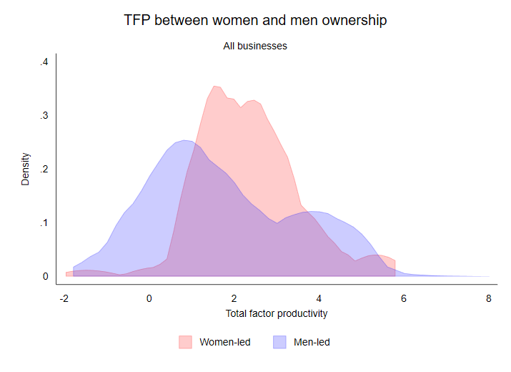 | 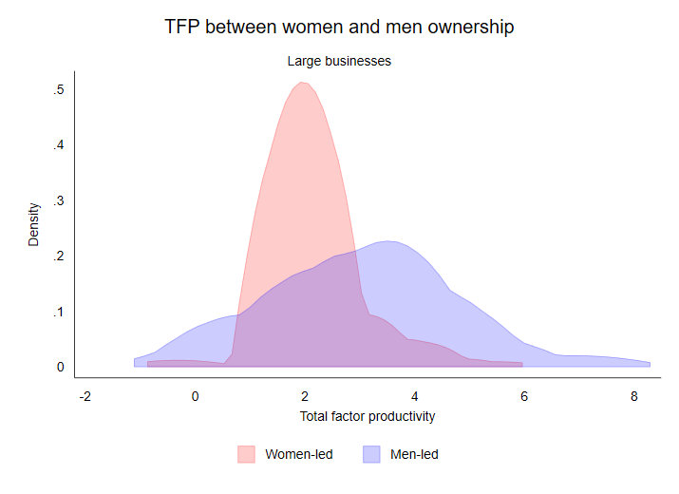
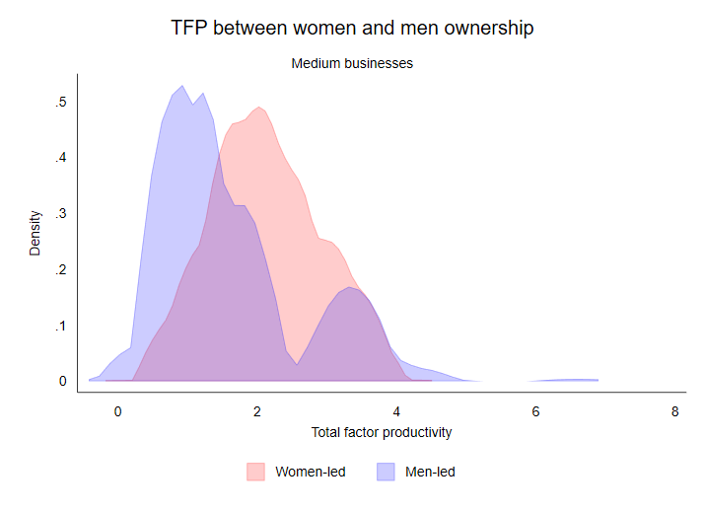 | 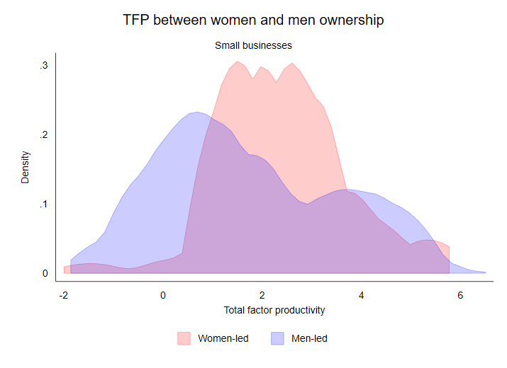
Source: Authors’ calculation based on ES 2023. Sampling weight is used.

Informal businesses
Women-led informal businesses exhibit higher sales performance relative to the composite index of management practices compared to their men-led counterparts (Figure 14). This finding suggests that women-led businesses generate greater sales than men-led businesses with an equivalent level of effective management practices. The result highlights the potential for women leaders to leverage management practices more efficiently or innovatively, leading to superior outcomes in sales performance. However, it is important to note that the composite index encompasses a range of practices, including customer and supplier engagement, operational planning, and financial recordkeeping. Each of these components contributes differently to overall performance, especially when the gender of ownership plays a role, as women and men may exhibit different approaches to management practices.
Figure 14: Sales performance estimates subject to management practices index
Source: Authors’ calculation based on ISES 2023.
Figure 15 shows that women-led informal businesses excel in customer and supplier engagement. Seeking customer feedback on potential new products and asking suppliers about great products are two key traits of women business owners. The findings suggest that these businesses are, in some ways, more effective at employing direct interactions with relevant stakeholders compared to men-led businesses. This strength in stakeholder engagement may stem from women business owners' tendency to prioritize relationship-building and active communication. Such practices not only enhance their understanding of market trends but also enable them to adapt their strategies more effectively to customer and supplier needs. By fostering trust and collaboration, women-led businesses can create a competitive advantage in their respective markets. These insights highlight the importance of leveraging interpersonal skills in driving business success, particularly in environments where customer and supplier dynamics are pivotal. However, addressing other managerial gaps could further amplify their impact and overall productivity.
Such gaps are clear in operations, planning, and recordkeeping, where men-led businesses significantly outperform women-led ones. While interpersonal skills matter to some extent, having a planned budget and sales targets is crucial for business sustainability. Recordkeeping, including simple financial statements and business or transaction records, is also essential, particularly for informal businesses aiming to grow larger. These findings suggest that while women-led businesses may excel in areas such as customer and supplier engagement, they often face challenges in more structured aspects of business management. The lack of formal planning and recordkeeping can hinder their ability to scale and secure external financing, which are critical components for growth. Improving these areas could not only enhance operational efficiency but also boost their competitiveness in the formal economy.
Figure 15: Gap in management practices compared to men-led businesses
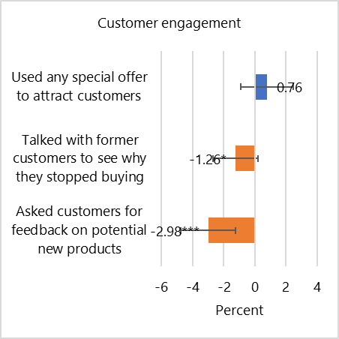 | 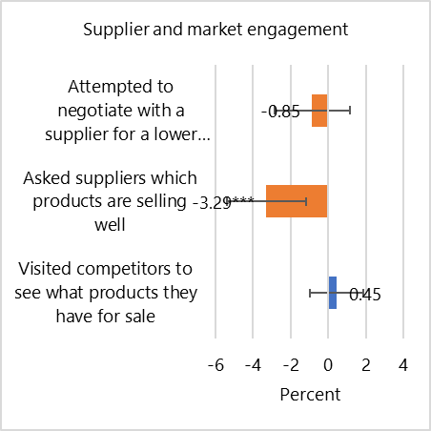
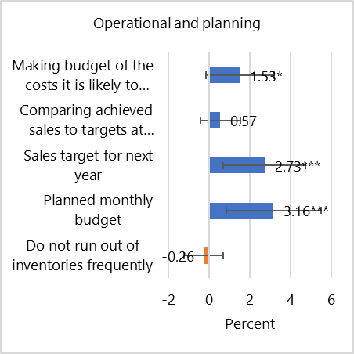 | 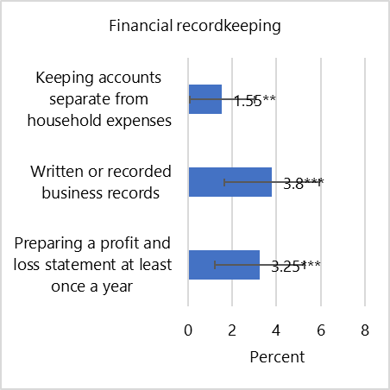
Source: Authors’ calculation based on ISES 2023.

Potential barriers to productivity
- While administrative reforms have improved permit processing times, larger businesses face increasing regulatory complexity, with no significant gender disparity in impacts.
- Bribery negatively affects the total factor productivity of both men- and women-led businesses.
- Illegal levies negatively affect labor productivity, particularly in informal women-led firms, while tax evasion attitude by men-led businesses correlates with lower labor productivity and foregone access to formal financial benefits.
- Over 90 percent of informal businesses lack awareness of licensing processes, highlighting the need for more robust government outreach and simplified registration procedures.
- High perceived costs and complexity deter formalization among businesses aware of licensing requirements, further underscoring the importance of accessible, transparent regulatory frameworks.

Formal businesses
Even though the time required for businesses to navigate regulatory processes has shown improvement over time (Figure 16), reflecting an overall trend towards greater efficiency in administrative procedures, as businesses grow in size, the complexity of coordinating and complying with policy implementation also increases in 2023 (Figure 17). This escalation in is observed across both women-led and men-led businesses, with no significant differences between the two groups. The positive trend in regulatory efficiency is also evident in the reduction of days needed for businesses to obtain construction, operational, and import permits, suggesting that reforms or streamlining efforts may have had a beneficial impact in these areas.
Figure 16: Percent of time spent dealing with government regulation | Figure 17: Percent of time spent dealing with government regulation across size
Source: Authors’ calculation based on ES. Sampling weight is used.
Despite this progress, the perception of the licensing process as a significant barrier has not improved over time (Figure 18). From 2015 to 2023, the duration required to secure import permits has, in fact, increased, affecting both women-led and men-led businesses equally (Figure 19). This growing challenge could have detrimental effects on business performance, particularly as the timely importation of raw materials and intermediate goods is crucial for maintaining export competitiveness, especially within the manufacturing sector. The increase in permit processing times may, therefore, represent a critical bottleneck that undermines the operational efficiency and global competitiveness of these firms, necessitating further examination and policy intervention to mitigate its impact.
Figure 18: Percent of firms identifying business licensing and permits as a major constraint | Figure 19: Days to obtain licenses and permits
Source: Authors’ calculation based on ES. Sampling weight is used.
While bribery was not found to be associated with labor productivity, it was negatively associated with total factor productivity (Figure 20). This indicates that corrupt practices can have an adverse impact on overall production efficiency. The negative association between bribery and Total Factor Productivity suggests that it may distort operational processes and hinder optimal resource utilization. The primary aim of regulatory frameworks is to safeguard public interests and address specific business concerns; however, excessively complex compliance requirements and cumbersome procedures for obtaining permits and licenses can inadvertently foster an environment conducive to bribery. Businesses may resort to corrupt practices to navigate and expedite these convoluted regulatory processes. Even though men-led businesses appear to be more adversely affected by these challenges compared to their women-led counterparts, it is imperative to cultivate a robust and equitable regulatory environment. Such an environment would facilitate enhanced and sustainable productivity across firms regardless of leadership gender.
Research has increasingly highlighted the role of social media and other information and communication technologies (ICTs) in combating corruption, recognizing that their proper use can significantly enhance national integrity systems. While it might be considered far-fetched to fully eliminate bribery and unofficial levies, digital one stop shops could be one of the solutions to reduce the likelihood of corruption. The platforms offer several key benefits in this regard: they automate processes and minimize personal interactions, thus reducing opportunities for collusion; eliminate intermediaries who often facilitate or demand bribes; increase transparency by making processes more trackable and open to auditing; and reduce bureaucratic red tape, which can serve as an entry point for corruption and extortion (Kukutschka 2016).
Figure 20: Productivity estimates of formal business subject to bribery
Source: Authors’ calculation based on ES 2023. Sampling weight is used.
Tax evasion is another critical issue that emerges within a similarly inefficient regulatory landscape. Recent research indicates that a significant share of registered firms in Indonesia admit to evading taxes, with one-quarter of firms engaging in this practice. This tax evasion results in an estimated revenue loss of around 2 percent of GDP (Alibhai, et al. 2024). Firms that face substantial competition from the informal sector, do not export, and perceive tax administration as a major obstacle are more likely to evade taxes. These findings suggest that the complexity of tax administration plays a pivotal role in driving non-compliance, as firms may evade taxes to remain competitive in an environment where informal sector firms often do not adhere to the same regulations. Similar to bribery, tax evasion can be mitigated by streamlining regulatory and tax compliance processes. Simplifying these processes and reducing unnecessary burdens could encourage firms to comply with tax regulations, thereby increasing tax revenue and fostering a more transparent, competitive business environment.

Informal businesses
Results are different in the informal sector: bribery is negatively associated with labor productivity in the women-led firms (Figure 21), imposing significant economic burdens on microenterprises. Although the ISES does not specify whether bribes are extracted by officials or non-officials, illegal levies are a pervasive issue within Indonesia's informal sector, affecting businesses such as kiosks and street vendors. These levies often represent a form of coercive rent extraction, further straining the resources of enterprises that already operate with limited capital and workforce. One may argue that these illegal levies could be theoretically categorized as a “rental rate” within a conventional production function. However, unlike legitimate operating costs, they provide no productive benefit or enhancement to business operations. Instead, such costs divert essential resources away from growth and hindering productivity.
Another constraint to labor productivity is the propensity among men-led businesses to engage in tax evasion (Figure 21). Notably, higher indices of tax evasion attitudes correlate with lower levels of labor productivity within these businesses. This relationship implies that while avoiding taxes may provide immediate financial relief, it could undermine operational efficiency and long-term business growth. Engaging in tax evasion may signal a focus on short-term financial gains at the expense of investments in productivity-enhancing resources, such as workforce development or technological upgrades. Additionally, by operating outside of tax compliance, these businesses may forgo access to government support mechanisms and formal sector benefits. For instance, eligibility for the People's Business Credit (KUR) program necessitates formal business registration as a prerequisite for obtaining bank credit. At present, the KUR program provides a preferential interest rate capped at 6 percent, which is approximately 10 percent lower than prevailing market rates (Alibhai, et al. 2024). Accordingly, businesses that remain non-compliant with tax regulations (i.e., lacking a formal business license) are precluded from leveraging such financial support initiatives.
Figure 21 also shows that unawareness of business licensing is also found to be negatively associated with the sales performance of the informal sector. Many entrepreneurs operating in this sector may lack the necessary knowledge regarding legal requirements and the importance of obtaining appropriate licenses. This gap in understanding can result in businesses operating outside the regulatory framework, limiting their ability to access various markets and customer segments. Consequently, the absence of proper licensing can lead to decreased consumer confidence, as customers may perceive unlicensed businesses as less credible or trustworthy.
Figure 21: Productivity and sales estimates of informal business subject to business constraint
Source: Authors’ calculation based on ISES 2023. Sampling weight is used.
More than 90 percent of businesses are not aware of business licensing practices (Figure 22). The widespread lack of awareness highlights a critical barrier to formalization and growth within the informal sector, where many businesses operate without understanding the regulatory requirements needed to legitimize their business. First, from the standpoint of informal businesses, there is limited interest concerning business registration and its associated benefits. Second, from the government’s perspective, there is insufficient dissemination of information regarding business registration processes and the potential incentives available to businesses.
For businesses already aware of registration requirements, time and cost represent major barriers to formalization. These challenges may stem from perceptions that business registration is prohibitively expensive and/or that the associated bureaucratic processes are excessively complex. Notably, 35.8 percent of businesses familiar with the Business Identification Number (NIB) report a lack of information regarding the actual registration process. This finding reinforces previous observations that government efforts in disseminating information on business registration have been insufficiently robust.
Figure 22: Awareness of business licensing and main reason to avoid registration
Source: Authors’ calculation based on ISES 2023. Sampling weight is used.

Technology adoption as catalysts for improving productivity
- Women-led and men-led businesses show no significant differences in areas such as research and development, process innovation, or quality certification.
- Women-led businesses lag nearly 10 percentage points behind men-led businesses in digital adoption, with disparities particularly evident in sales-related functions and overall digital investment.
- Digital investment boosts sales for both men- and women-led businesses, though men-led firms report greater sales changes. As businesses adopt advanced technologies, the productivity gap between men- and women-led firms diminishes, emphasizing the importance of promoting access to sophisticated digital tools.
- Digital tools, especially social media, positively impact sales in informal businesses. While employee digital proficiency is less critical, business leaders' digital skills significantly influence operational success, underscoring the need for training programs to improve digital readiness in the informal sector.
There is no significant difference between women-led and men-led businesses in areas such as research and development, process innovation, new product or service development, and quality certification. This indicates that both types of businesses engage similarly in these critical technological areas. Similar findings from the World Bank's Firm-level Adoption of Technology (FAT) survey indicate minimal to no variation in the adoption of advanced technology across general business functions at both the extensive and intensive margins (Cirera, et al. 2024).
However, there is a considerable disparity related to digital technology adoption: women-led businesses lag behind their men-led counterparts by nearly 10 percentage points in terms of digital transition and investment, as depicted in Figure 23. This gap highlights a significant area of divergence between the two groups, particularly in their integration and utilization of digital technologies. As illustrated in Figure 24, women-led businesses tend to fall behind in nearly all aspects of digital usage, with the notable exception of sales-related functions. The positive association between digital transition and increased sales expectations, as well as the observed increase in sales associated with digital investment, underscores the importance of promoting digitalization. To address this gap, it is crucial to implement targeted initiatives that support and encourage digital adoption among women-led enterprises. By fostering a more supportive digital environment, it is possible to enhance the competitive standing and operational efficiency of women-led businesses, thereby contributing to more equitable technological advancement across the business sector.
Figure 23: Technological and digital adoption | Figure 24: Digital transition utilizations
Source: Authors’ calculation based on ES 2023 and BPS round 5. Sampling weight is used. | Source: Authors’ calculation based on BPS round 5. Sampling weight is used.
As businesses grow, the level of digital transition increases, regardless of leader’s gender (Figure 25). It must be noted however that not all businesses are engaging in this transition: at least 30 percent of men-led and 40 percent of women-led small businesses have yet to undergo a digital transition. Additionally, digital investment remains limited across both men-led and women-led businesses, particularly among small businesses, with none exceeding a 10 percent investment threshold compared to their medium and large counterparts. Notably, disparities begin to manifest in medium and large enterprises. In medium-sized firms, men-led businesses exhibit a tendency to invest 5 percentage points more in digital transition compared to their women-led counterparts. Conversely, in large enterprises, women-led firms surpass their men-led counterparts, with 8 percentage points higher investment.
When examining the impact of digital investment on sales, estimates indicate that men-led businesses experience a greater sales change from such investments (Figure 26). Despite this disparity, empirical evidence supports the notion that digital investment significantly enhances a business’ sales, even if it does not directly translate to increased productivity. Cirera, et al. (2024) underscore that businesses managed by women achieve lower productivity returns from less advanced technologies. However, as the level of technological sophistication increases—particularly when firms deploy machines that necessitate human interaction, such as computers with basic software—there is a notable convergence in productivity outcomes between men-led and women-managed enterprises. The benefits of technology further intensify with the comprehensive digitalization of business functions, and the adoption of more advanced technologies serves to mitigate the productivity gap. Consequently, there is a critical need for more accessible digital investment opportunities for businesses, not only to improve sales but also to potentially serve as a catalyst for more sustainable productivity growth.
Figure 25: Digital adoption between gender leadership and size | Figure 26: Sales change estimates subject to digital adoption between gender leadership
Source: Authors’ calculation based on BPS round 5. Sampling weight is used. | Source: Authors’ calculation based on all rounds of BPS. Sampling weight is used.
Similar findings are evident in the informal sector, where the utilization of digital equipment is positively correlated with sales performance (Figure 27). While the proficiency of workers in computer use does not exhibit a significant relationship with sales outcomes, the use of social media for business operations—such as serving customers and engaging with suppliers for inputs—demonstrates a positive correlation with sales performance. This suggests that, at present, digital proficiency among informal employees may not substantially influence microbusinesses. In contrast, the digital proficiency of business leaders significantly impacts sales performance through their daily operational activities. Furthermore, as the digital landscape continues to evolve, businesses that leverage digital tools effectively are likely to gain a competitive advantage in their respective markets. Investing in digital skills training for employees may also foster a more innovative and adaptable workforce, better equipped to respond to changing consumer demands.
Figure 27: Sales performance estimates of informal sector subject to digital adoption
Source: Authors’ calculation based on ISES 2023. Sampling weight is used.

Policy recommendations
To address the gender disparities in productivity and support women’s leadership across formal and informal sectors in Indonesia, holistic interventions should be prioritized. The following recommendations are intended to enhance equitable business development, support digital and technological integration, and reduce regulatory barriers for women-led enterprises, thus fostering a conducive environment for women’s economic participation and productivity.

Simplify regulatory processes and enhance accessibility of business licensing
Sharing information about licensing processes and streamlining administrative procedures are essential to encouraging the formalization of informal enterprises. Policies should focus on reducing the time and costs associated with business registration, enhancing procedural transparency, and clearly articulating the benefits of formalization to potential registrants. The establishment of simplified digital registration systems, along with localized informational hubs, would improve accessibility and comprehension of formal sector requirements for informal business operators, thereby encouraging formalization and subsequent access to formal sector benefits.

Strengthen legal frameworks to mitigate corruption and unofficial levies
Reducing bribery and unofficial levies within the formal and informal sectors is essential for lowering operational costs and fostering a more enabling business environment for women-led enterprises. Strengthening legal enforcement against corrupt practices, alongside creating secure, accessible reporting mechanisms, would help mitigate these barriers. Public information campaigns that raise awareness of legal rights and protections could further empower women entrepreneurs to operate within a regulated and secure environment, free from coercive practices. Additionally, the adoption of digital platforms could reduce the risk of bribery and unofficial levies by minimizing person-to-person interactions, thereby enhancing transparency and accountability in business transactions.

Support gender-sensitive workplace policies and leadership development programs
Implementing inclusive workplace policies that cater to the unique needs of women, such as flexible working arrangements, is integral to enhancing productivity and workforce retention in women-led enterprises. Furthermore, leadership development initiatives specifically aimed at advancing women in managerial and decision-making roles would help close the gender gap in top leadership positions across both the formal and informal sectors. Cultivating a pipeline of women leaders is essential for ensuring sustained gender diversity in strategic decision-making and enterprise growth.

Providing targeted incentives and promoting for digital technology adoption among women-led businesses
Fostering technology adoption among women-led small and medium enterprises is critical to enhancing productivity and competitive edge. Government policies could include tax incentives, grants, and subsidies that specifically support technological and digital investments in women-led firms. Additionally, a dedicated technology adoption fund targeting these enterprises could enable broader access to advanced digital tools, thereby strengthening operational efficiencies and productivity outcomes across sectors.
Private sector firms that invest in training their own employees on digital skills, automation, and advanced technologies set a precedent for best practices that can be shared with women-led SMEs. Such companies not only create a skilled workforce internally but also contribute to a broader culture of digital fluency and innovation. By forming partnerships with private providers, women-led SMEs could access specialized training programs on digital tools and automation technologies, tailored to their unique business needs. Aligning government support with private sector training initiatives can thus drive sustainable technological adoption across women-led SMEs, enhancing their competitive edge and resilience in an increasingly digital economy.

Strengthen vocational training and education initiatives
Enhancing access to vocational training and skill-development programs tailored to women is essential, particularly in sectors where gender disparities in productivity and leadership remain significant. Such initiatives empower women entrepreneurs and workers to boost their competitiveness and productivity. Programs like the Pre-employment Card have demonstrated the potential of targeted training, showing measurable impacts such as increased average incomes—especially among women beneficiaries. Scaling up and investing in these proven approaches can further promote economic advancement and gender equity in the workforce. Providing training is quite crucial, given recent finding underscores the impact of such initiatives.

References
Alibhai, Salman, Hillary C. Johnson, Cecile Thioro Niang, and Francesco Strobbe. 2024. "Can Public Credit Schemes Improve Access to Finance for Small Business? Evidence from Indonesia." Policy Research Working Paper (World Bank). http://documents1.worldbank.org/curated/en/099257009042435538/pdf/IDU12698ff2e1c4be1400518dec1e349ef771a96.pdf.
Cirera, Xavier, Marcio Cruz, Antonio Martins-Neto, Kyung Min Lee, and Caroline Noguira. 2024. "The Role of Technology in Reducing the Gender Gap in Productivity." Policy Research Working Paper (World Bank). http://documents1.worldbank.org/curated/en/099701005152432429/pdf/IDU19d64fdd31725014bd11a04b1ee26fb7aba61.pdf.
Coordinating Ministry for Economic Affairs of the Republic of Indonesia. 2021. Program Management Report. Jakarta: Coordinating Ministry for Economic Affairs of the Republic of Indonesia. https://public-prakerja.oss-ap-southeast-5.aliyuncs.com/www/ebook-reporting/Laporan-Manajemen-Pelaksana-Program-Kartu-Prakerja-Tahun-2021-English.pdf.
Fang, Sheng, Chorching Goh, Mark Roberts, Lixin Colin Xu, and Albert Zeufack. 2020. "Female Business Leaders, Business and Cultural Environment, and Productivity Around the World." Policy Research Working Paper (World Bank). https://openknowledge.worldbank.org/server/api/core/bitstreams/e4840a26-c89a-5e6e-a8b0-cd891353d78f/content.
Hapsari, Indira Maulani, Shu Yu, Johann Utz Pape, and Wael Mansour. 2023. "Informality in Indonesia: Levels, Trends, and Features." Policy Research Working Paper (World Bank). https://openknowledge.worldbank.org/bitstreams/cc726cd9-b6bc-4ee0-aa3a-13bd50639101/download.
Hoy, Christopher Alexander, Filip Jolevski, and Sheannal Anthony Manindha Obeyesekere. 2024. "Revealing Tax Evasion: Experimental Evidence from a Representative Survey of Indonesian Firms." Policy Research Working Paper (World Bank). https://documents1.worldbank.org/curated/en/099358407222411531/pdf/IDU18ac8f51d1c91e14f751936b1e28e9f364a0b.pdf.
ILO. 2020. "Leading to Success: The Business Case for Women in Business." ILO Brief (International Labour Organization). https://www.ilo.org/media/396226/download.
Kukutschka, Roberto Martínez Barranco. 2016. "Technology Against Corruption: The Potential of Online Corruption-reporting Apps and Other Platforms." U4 Expert Answer (U4). https://www.u4.no/publications/technology-against-corruption-the-potential-of-online-corruption-reporting-apps-and-other-platforms.pdf.
Saliola, Federica, and Murat Seker. 2011. "Total Factor Productivity Across the Developing World." Enterprise Note (World Bank). http://documents1.worldbank.org/curated/en/646931468157519398/pdf/682730BRI0ESN00LIC00Productivity023.pdf.

This issue has been prepared by a World Bank team composed of Alexandre Laure (Senior Private Sector Specialist), Marie Christine Apedo Amah (Senior Economist), Bayu Agnimaruto (Research Analyst), Agnesia Adhissa (Private Sector Specialist). It has been peer reviewed by Filip Jolevski (Economist) and Komal Mohindra (Senior Private Sector Specialist).
Business sizes are defined as follows: micro (0-4 workers), small (5-19 workers), medium (20-99 workers), and large (100 or more workers).
The Enterprise Surveys (ES) provide various definitions for women-led firms, such as female participation in ownership, firms with a top female manager, or firms with majority female ownership. Conversely, the ISES only recognizes firms where most owners are female. To harmonize the definition of 'women-led' in the ISES with one of the ES definitions, the issue uses firms with at least one female owner.
The Adult Population Survey (APS) data from both 2015 and 2020, collected by the GEM, show that men and women entrepreneurs in Indonesia are evenly distributed, each comprising about 50 percent. These numbers are calculated by the authors using the national sampling weights provided by GEM.
Key policies and programs include: (i) West Java (Perda No. 5 Year 2021 on Gender Mainstreaming and Women’s Empowerment); (ii) East Java (Perda No. 9 Year 2014 on UMKM (Micro, Small, and Medium Enterprises) eases formalization for women-led micro businesses and Perda No. 8 Year 2016 on Gender Mainstreaming supports women’s economic empowerment through local programs for business formalization); (iii) Bali (Perda No. 3 Year 2019 on Women’s Empowerment and Gender Equality offers support for women entrepreneurs in tourism and handicrafts, including formalization aid); (iv) South Sulawesi (Perda No. 6 Year 2017 on Gender Mainstreaming in Development promotes women’s economic participation and provides formalization resources for women-led businesses); (v) Special Region of Yogyakarta (Perda No. 5 Year 2017 on Women’s Empowerment and Child Protection includes business training and licensing support to aid formalization for women entrepreneurs); (vi) Central Java (Perda No. 3 Year 2021 on Gender Equality and Women’s Empowerment mandates local government support for women-led businesses, including microfinance and other resources).
The World Bank's BPS round 4 estimates showed that the change in sales for exporters from the previous round 3 was higher than for non-exporters. The round 5 survey provided significant estimates indicating that firms engaged in both importing and exporting experienced increased sales compared to the pre-COVID-19 period.
Labor productivity measured as the log sales per worker. Estimates control for size, business age, foreign or domestic ownership, training, exporter, and importer. *** p < 0.01, ** p < 0.05, * p < 0.1
Total factor productivity (TFP) measures the ratio of total outputs to the total inputs used in producing those outputs (Saliola and Seker 2011). It can thus be defined as the effectiveness with which firms transform inputs into outputs.
Sales performance in the informal sector is estimated using sales from the previous month. The regression controls for owner characteristics (age, prior experience, high school completion, and holding another job) as well as business characteristics (sector, use of home as business premises, businesses as main customers, and businesses as main suppliers). *** p < 0.01, ** p < 0.05, * p < 0.1
Gaps are calculated as the share of each management practice in men-led businesses minus that in women-led businesses, with a t-test evaluating significance. *** p < 0.01, ** p < 0.05, * p < 0.1
Labor productivity and total factor productivity of formal sector are estimated using value added approach. All regressions control for size, business age, foreign or domestic ownership, training, exporter, and importer. *** p < 0.01, ** p < 0.05, * p < 0.1
Tax evasive attitude index ranges from 0-3 with a higher index indicating a greater likelihood of a business being prone to evading taxes. The index is constructed from three perception-based questions in the ISES. First, respondents are asked whether they believe the government always has the right to require businesses to pay taxes. Second, the index includes a statement that businesses should refuse to pay taxes until they receive better services from the government. Finally, respondents are asked to consider the importance of businesses paying taxes.
The FAT survey defines general business functions to include business administration, production planning, sourcing and procurement, marketing and customer information, sales, payment methods, and quality control.
The BPS defines digital transition as the use of equipment for various business functions, including marketing, selling, delivery services, payment processing, supply chain management, business administration, and production planning. In contrast, digital investment refers specifically to the acquisition of digital-related equipment or software.
BPS round 3, 4, and 5 panel sample are used in the estimation. Strata, size, and province are used as controls.
Balanced panel samples from all rounds of BPS are used in the estimation. Strata, size, and province are used as controls. *** p < 0.01, ** p < 0.05, * p < 0.1
The Pre-employment Card program improved the average income of previously unemployed beneficiaries by 32 percent, with women beneficiaries experiencing an income increase of 33 percent relative to non-beneficiaries (Coordinating Ministry for Economic Affairs of the Republic of Indonesia 2021). The evidence highlights the potential of targeted training programs to contribute significantly to economic advancement and gender equity in the workforce.

